**PIZZA SALES SQL QUERIES:**

1. **KPI’s:**
2. **Total Revenue:**

SELECT SUM(total_price) AS Total_Revenue FROM pizza_sales

1. **Average Order Value:**

SELECT SUM(total_price) / COUNT(DISTINCT order_id) AS Avg_Order_Value FROM pizza_sales

1. **Total Pizzas Sold:**

SELECT SUM(quantity) AS Total_pizza_sold FROM pizza_sales

1. **Total Order:**

SELECT COUNT (DISTINCT order_id) AS Total_Orders FROM pizza_sales

1. **Average Pizzas Per Order:**

SELECT CAST(CAST(SUM(quantity) AS DECIMAL (10,2)) /

CAST(COUNT(DISTINCT order_id) AS DECIMAL (10,2)) AS DECIMAL (10,2))

AS Avg_Pizzas_Per_Order

FROM pizza_sales

1. **Daily Trend for Total Orders:**

SELECT DATENAME(DW, order_date) AS order_day, COUNT(DISTINCT order_id) AS total_orders

FROM pizza_sales

GROUP BY DATENAME(DW, order_date)

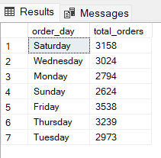

1. **Monthly Trend for Total Orders:**

SELECT DATENAME(MONTH, order_date) AS Month_Name, COUNT(DISTINCT order_id)

AS Total_Orders

FROM pizza_sales

GROUP BY DATENAME(MONTH, order_date)

1. **% of Sales by Pizza Category:**

SELECT pizza_category, CAST(SUM(total_price) AS DECIMAL(10,2)) AS total_revenue,

CAST(SUM(total_price) * 100 / (SELECT SUM(total_price) FROM pizza_sales)

AS DECIMAL(10,2)) AS PCT

FROM pizza_sales

GROUP BY pizza_category

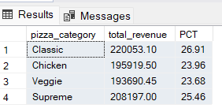

1. **% of Sales by Pizza Size:**

SELECT pizza_size, CAST(SUM(total_price) AS DECIMAL(10,2)) AS total_revenue,

CAST(SUM(total_price) * 100 / (SELECT SUM(total_price) FROM pizza_sales)

AS DECIMAL(10,2)) AS PCT

FROM pizza_sales

GROUP BY pizza_size

ORDER BY pizza_size

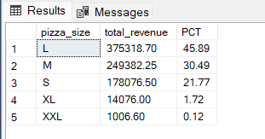

1. **Total Pizzas Sold by Pizza Category:**

SELECT pizza_category, SUM(quantity) AS Total_Quantity_Sold

FROM pizza_sales

WHERE MONTH(order_date) = 2

GROUP BY pizza_category

ORDER BY Total_Quantity_Sold DESC

1. **Top 5 Pizzas by Revenue:**

SELECT Top 5 pizza_name, SUM(total_price) AS Total_Revenue

FROM pizza_sales

GROUP BY pizza_name

ORDER BY Total_Revenue DESC

1. **Bottom 5 Pizzas by Revenue:**

SELECT Top 5 pizza_name, SUM(total_price) AS Total_Revenue

FROM pizza_sales

GROUP BY pizza_name

ORDER BY Total_Revenue ASC

1. **Top 5 Pizzas by Quantity:**

SELECT Top 5 pizza_name, SUM(quantity) AS Total_Pizza_Sold

FROM pizza_sales

GROUP BY pizza_name

ORDER BY Total_Pizza_sold DESC

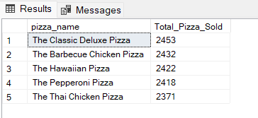

1. **Bottom 5 Pizza by Quantity:**

SELECT Top 5 pizza_name, SUM(quantity) AS Total_Pizza_Sold

FROM pizza_sales

GROUP BY pizza_name

ORDER BY Total_Pizza_sold ASC

1. **Top 5 Pizza by Total Order:**

SELECT Top 5 pizza_name, COUNT(DISTINCT order_id) AS Total_Orders

FROM pizza_sales

GROUP BY pizza_name

ORDER BY Total_Orders DESC

1. **Bottom 5 Pizzas by Total Orders:**

SELECT Top 5 pizza_name, COUNT(DISTINCT order_id) AS Total_Orders

FROM pizza_sales

GROUP BY pizza_name

ORDER BY Total_Orders ASC

